User Requirements for Drivers

Invoices

1. The AkiProPlus system is expected to provide the means for a driver to have login credentials for the application.
2. The AkiProPlus system is expected to provide the means for a driver to see which invoices are on his route for that particular delivery day.
3. The AkiProPlus system is expected to provide the means for a driver to import those invoices from the system to the terminal.
4. The AkiProPlus system is expected to provide the means for a driver to print those invoices

Returns

1. The AkiProPlus system is expected to provide the means for a driver to view the deliveries made in the past to know which customers may have goods to return.
2. The AkiProPlus system is expected to provide the means for a driver to view those items that was delivered for a specific day selected.
3. The AkiProPlus system is expected to provide the means for a driver to import this information from the server to the terminal.
4. The AkiProPlus system is expected to provide the means for a driver to make data entries on goods return.
5. The AkiProPlus system is expected to provide the means for a driver to edit those changes made on return goods (in case an error was made).
6. The AkiProPlus system is expected to provide the means for a driver to save those changes on the terminal.
7. The AkiProPlus system is expected to provide the means for a driver to print return slips
8. The AkiProPlus system is expected to provide the means for a driver to synchronize all changes saved on the terminal to the main server.

Receivables

1. The AkiProPlus system is expected to provide the means for a driver to generate a credit note.
2. The AkiProPlus system is expected to provide the means for a driver to generate a debit note.

System Requirements

1. The AkiProPlus system should function on an android OS.
2. The AkiProPlus system should back-up all updates made to the terminal.
3. The AkiProPlus system, driver’s application should connect to the main server.
4. The AkiProPlus system should validate user credentials.

Use Cases

|  |  |  |  |
| --- | --- | --- | --- |
| Use Case Number | | 1 | |
| Use Case Name | | Importing customer invoices | |
| Related Requirements | | Delivery Day | |
| Goal in Context | | To store customer invoices on tablet terminal | |
| Pre-Condition | | User Log in successfully | |
| Successful End Condition | | Information imported to terminal without errors | |
| Fail End Condition | | An error occurred while importing invoices | |
| Primary Actors | | Driver | |
| Secondary Actors | | Office Manager | |
| Trigger | | Invoices are required for drivers daily transactions | |
| Main Flow | Step | | Action |
|  | 1 | | User log in to the application |
|  | 2 | | Specify the delivery day in the “delivery day” combo box |
|  | 3 | | Click on the customer invoice button |
|  | 4 | | Select invoices to import with the checkboxes |
|  | 5 | | Click the import button |

|  |  |  |  |
| --- | --- | --- | --- |
| Use Case Number | | 2 | |
| Use Case Name | | Importing delivery history data | |
| Related Requirements | | Orders delivered for the week | |
| Goal in Context | | To determine who may have goods to return | |
| Pre-Condition | | User Log in successfully | |
| Successful End Condition | | Data imported successfully | |
| Fail End Condition | | An error occurred while importing the data | |
| Primary Actors | | Driver | |
| Secondary Actors | | Office Manager | |
| Trigger | |  | |
| Main Flow | Step | | Action |
|  | 1 | | User log in to the application |
|  | 2 | | Select a day in the past under “delivery history” |
|  | 3 | | Click on view history |
|  | 4 | | Select the items you would like to import |
|  | 5 | | Click on the import button |
| Use Case Number | | 3 | |
| Use Case Name | | Returning goods | |
| Related Requirements | | Item name, Invoice ID | |
| Goal in Context | | Making changes to the system as they occur | |
| Pre-Condition | | User Login successfully | |
| Successful End Condition | | Information synched from terminal without errors | |
| Fail End Condition | | Information was unable to sync to the server | |
| Primary Actors | | Driver | |
| Secondary Actors | | Office Clerk | |
| Trigger | | The shelf life of goods have expired | |
| Main Flow | Step | | Action |
|  | 1 | | User log in to the application |
|  | 2 | | Import data on the delivery history for a particular day |
|  | 3 | | Once imported click on the edit button |
|  | 4 | | Enter the amount return and return date in the returns data entry form. |
|  | 5 | | Click on the view changes button. |
|  | 6 | | Once the data is accurate click save |
|  | 7 | | Then click on the print button for return slips |
|  | 8 | | The sync button is to be clicked only when you are on the office compound. |

|  |  |  |  |
| --- | --- | --- | --- |
| Use Case Number | | 4 | |
| Use Case Name | | Addressing discrepancies | |
| Related Requirements | | Invoice No., Credit Note No. and Debit Note No. | |
| Goal in Context | | Issuing debit and credit notes | |
| Pre-Condition | | User Log in successfully | |
| Successful End Condition | | No conflicts with updated customer information | |
| Fail End Condition | | Conflict arise with the issued notes numbers | |
| Primary Actors | | Driver | |
| Secondary Actors | | Office Clerk | |
| Trigger | | Discrepancy with orders | |
| Main Flow | Step | | Action |
|  | 1 | | User login to the application |
|  | 2 | | Once the invoices were imported click on the “details” button |
|  | 3 | | Click on the “generate credit note” or “generate debit note” button |

Data flow diagram for Driver’s application







Entity Relationship Diagram For Drivers Application

Returns 

Assumptions:

* Each Invoices would reflect one order
* Orders will generate one invoice for a customer
* On every invoice you can have one return
* Each return can only be associated with one Invoice
* A return must have a returned order item
* Multiple Order items can have the same ReturnID
* An order can have many items return
* A returned order item must be attached to an order

Invoices



Activity Diagram for entering data on returns



AkiProPlus Driver’s Application Interface Design

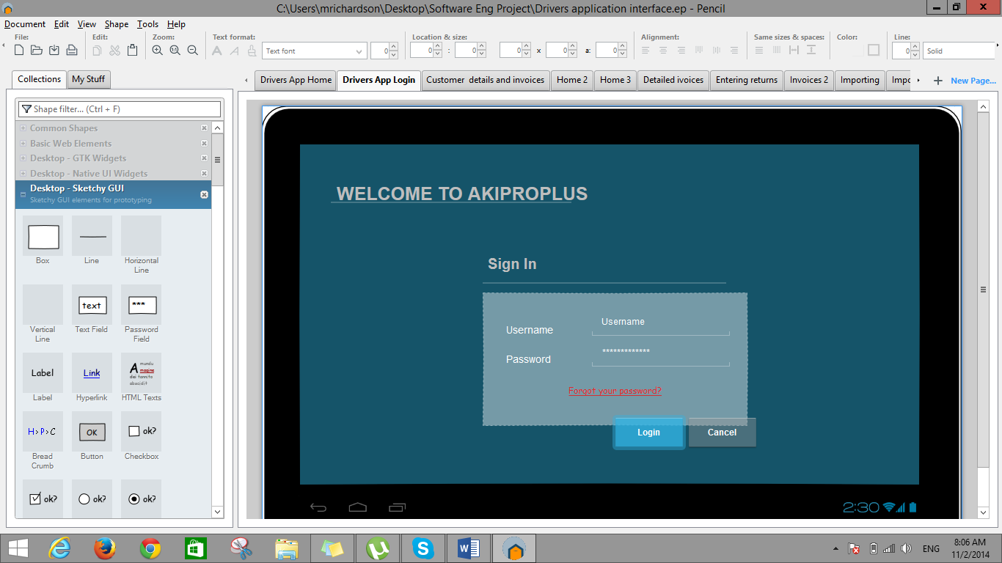

Figure 1: Login page

Description:

In figure 1 above demonstrates the login process of Akiproplus. The user would be assigned a username and password in order to enter the application and the system will verify the user’s credential. In the case where a user forgot their password, the “Forgot your password?” link will take the user to another page where the system will acquire the Driver’s ID for verification purposes, and allow them to reset their password.

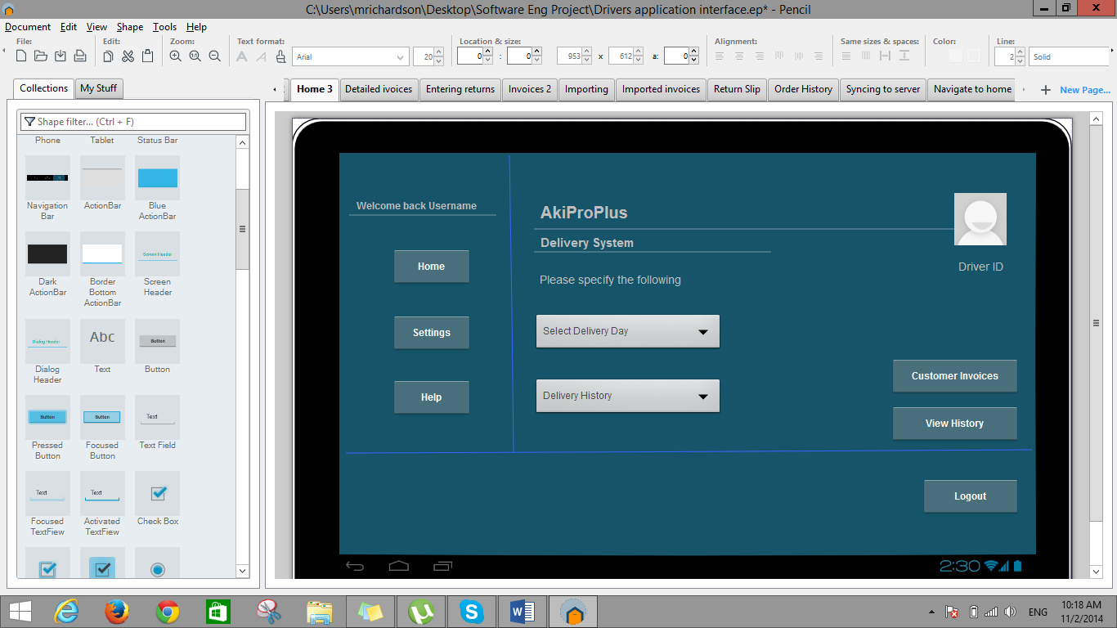 Figure 2: Homepage

Description:

Once the login credentials have been verified and the user have successfully logged into the application, they will be taken to the application’s homepage. The navigation bar for the application consist of a home, settings and help button. The home button will allow the user to navigate to the homepage displayed in figure 2 above once he’s on another page. The settings button will allow the user to perform functions such as changing their personal information that have been stored to their profile such as their username or password. Finally the help button should be able to assist the user in troubleshooting any problems the user can potentially encounter while using the application. At the footer of the application homepage there is a logout button. This button should allow the user to logout of the application once all daily operations are completed.

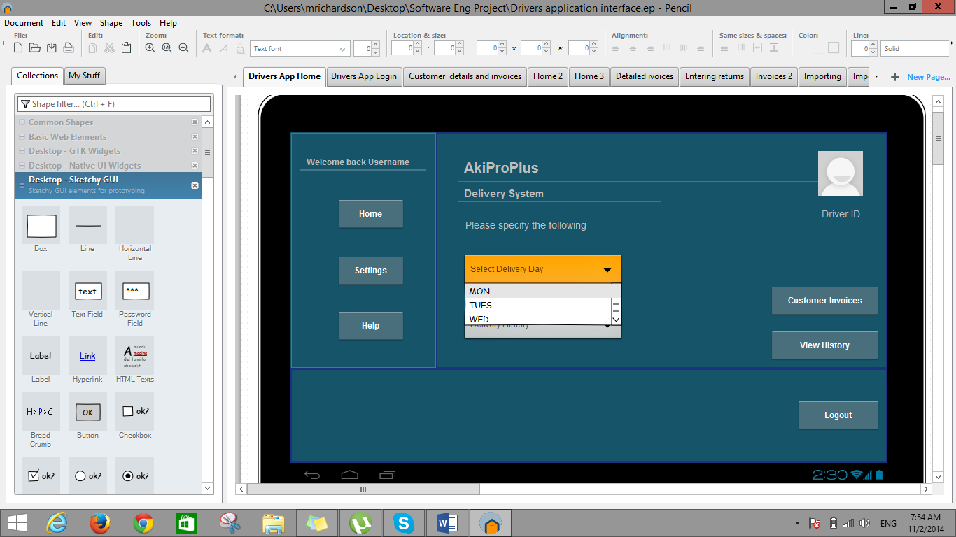

Figure 3: Importing Invoices

Description:

Figure 3 demonstrates the first stage on how a user will import customer invoices from the server to the user respective android terminal.

Step 1

* The user must select a day in which deliveries are to be made. In other words if he’s about to begin his daily operations for Monday he’ll select his delivery day as Monday.

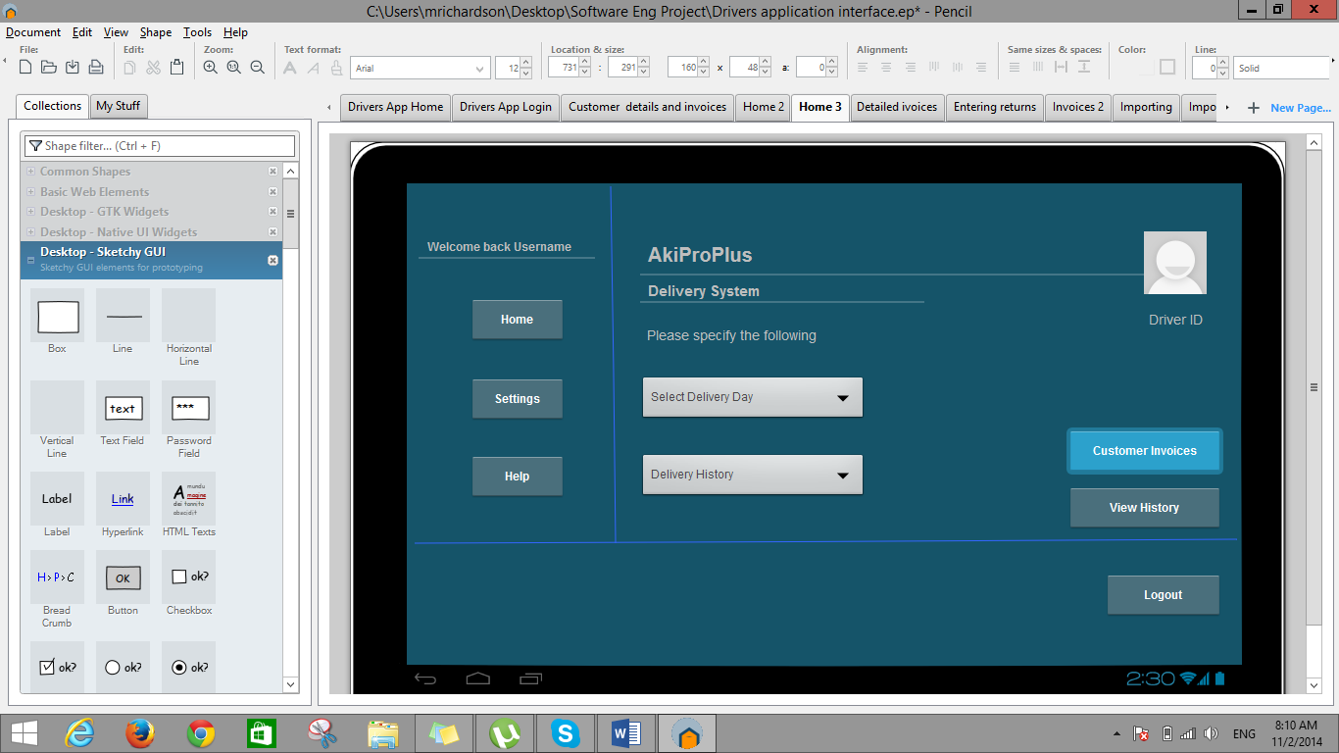

Figure 3.1

Description:

Step 2

* After the delivery day have been selected the user then clicks on the Customer Invoices button which will then navigate to a list of all invoices for the selected day

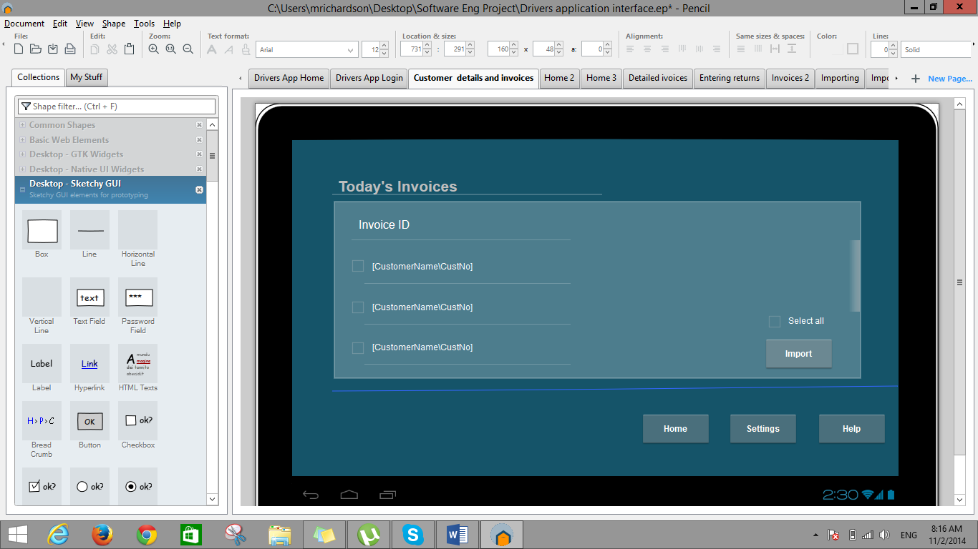

Figure 3.2

Description:

Step 3

* The user can now see the invoice listing of all customers for his specified delivery day and proceeds to import all these invoices from the server to his tablet terminal. It is crucial to note that this action of importing the invoices must be done before he proceeds to perform any of his daily operations.

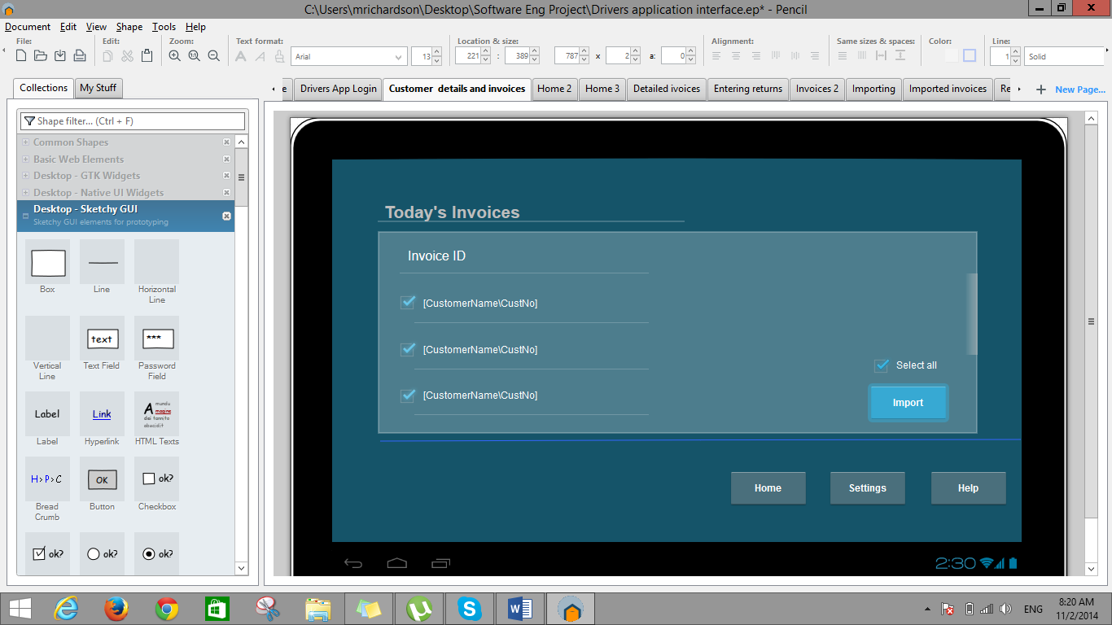

Figure 3.3

Description:

Step 2 (cont’d)

* The user can check each invoice individually and import them or simply check the select all box and then click on the import button to execute the import process.

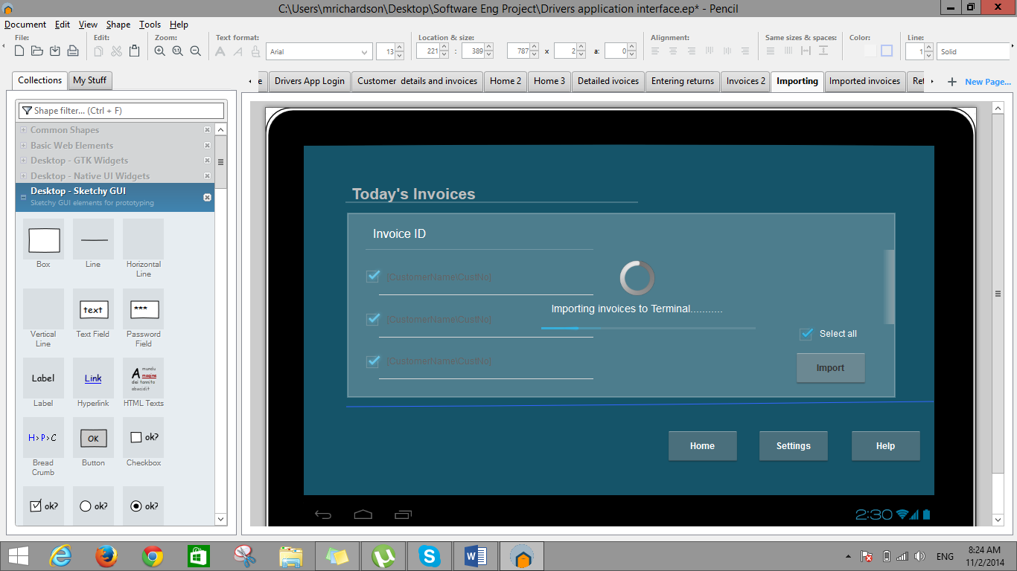

Figure 3.4

Description:

Step 2 (cont’d)

* The interface notifies the user that the invoices are in the process of being imported.

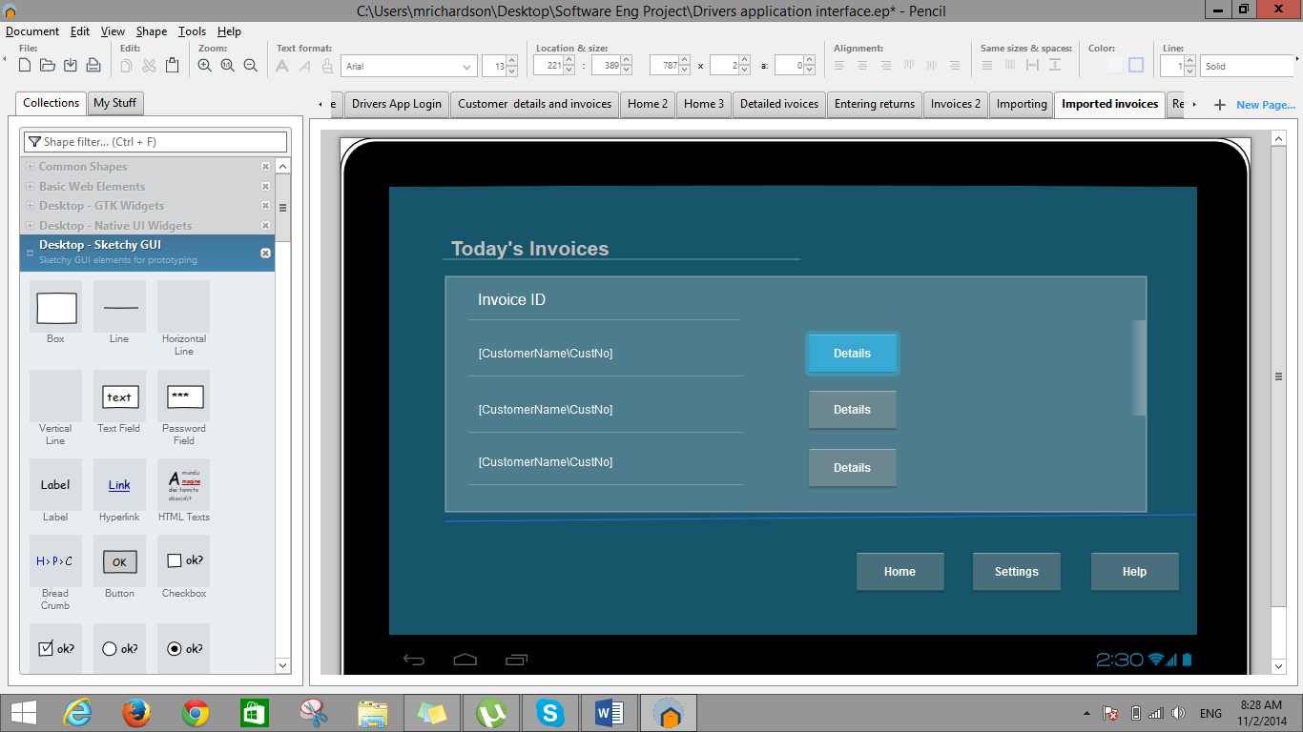

Figure 3.5

Description:

Step 2 (cont’d)

* Once the invoices have imported successfully the user should only see the interface displayed in Figure 3.5 when they click on the customer invoice button. This is due to the invoices already existing on the tablet for the specified day under the combo box for delivery day.

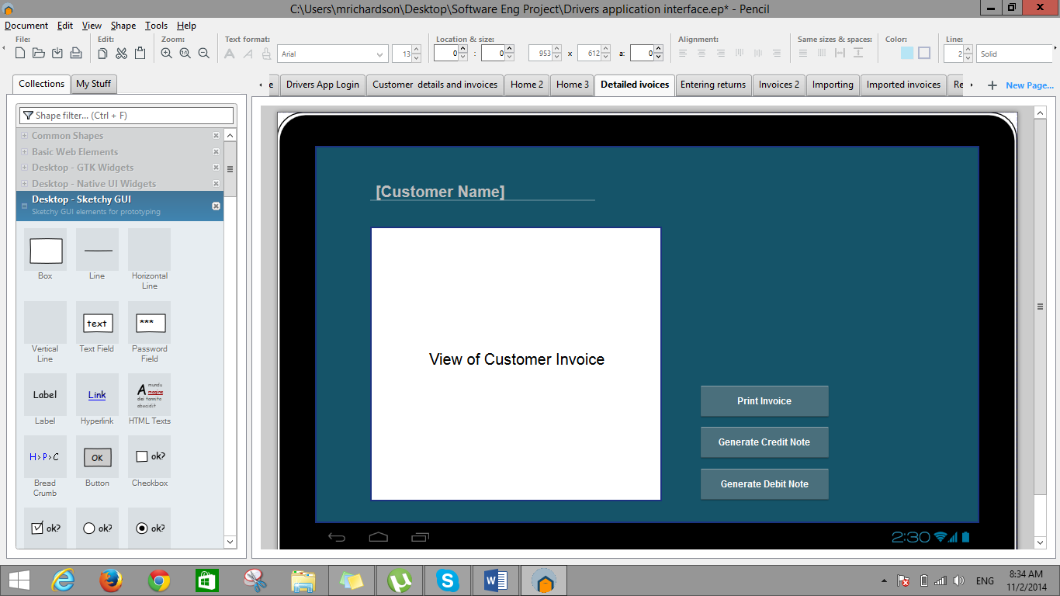

Figure 4

The user must click on the tablets back button to navigate to the previous page

Description:

* When the user clicks on the details button in figure 3.5 he’ll then see the interface displayed in figure 4. The user now have the option to print the invoice or in the case of a discrepancy generate a credit note or a debit note.

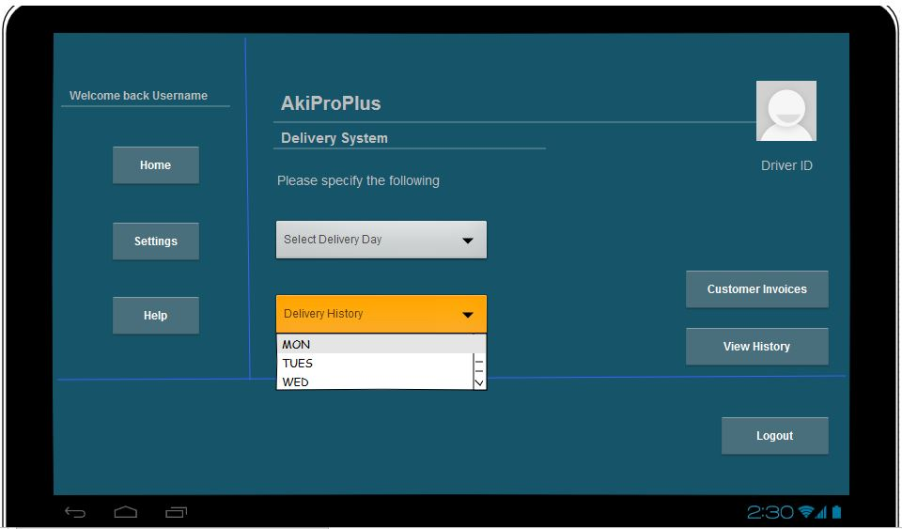

Figure 5: Importing delivery information on goods that have already been delivered

Description:

Step 1

* Figure 5 above demostrates how the combo box for delivery history functions. The user has the option to select a day from during the week. The day selected has to do with the shelf life of an item, so if an item shelf life is 3 days the user will select the day, 3 days from the current day.

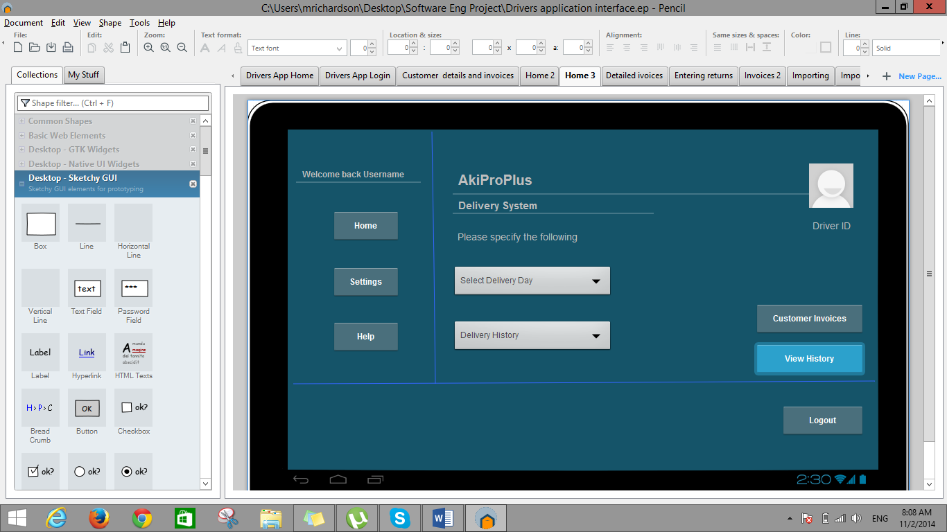

Figure 5.1

Description:

Step 2

* After the day has been selected the user then clicks on the view history buttons where he should see the listing of items that were delivered on the day specified under the delivery history combo box.

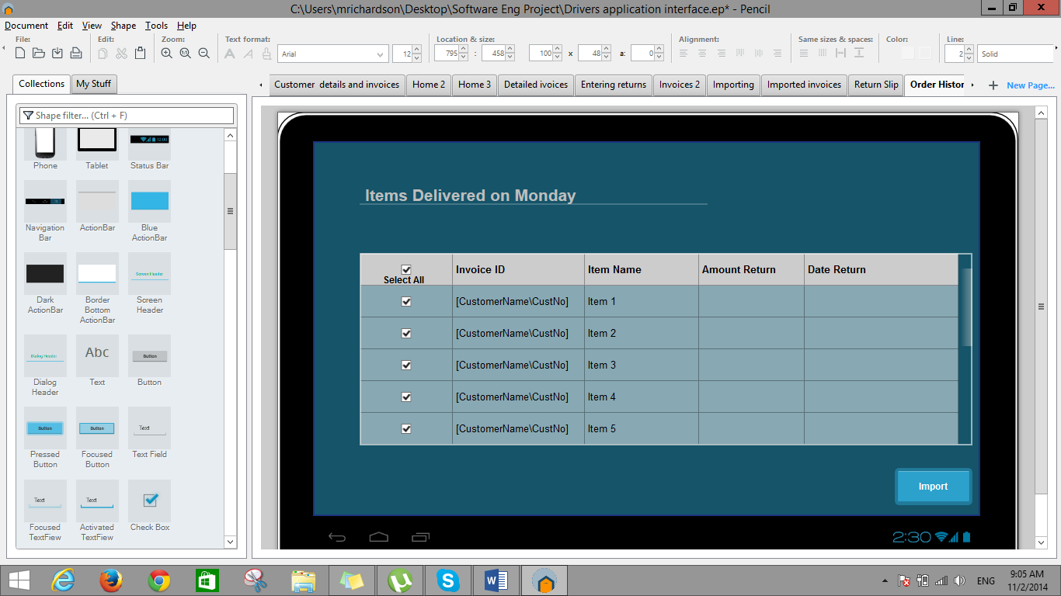

Figure 5.2

Description:

Step 3

* The user now has to import this information from the server to the terminal of the tablet by clicking the import button.

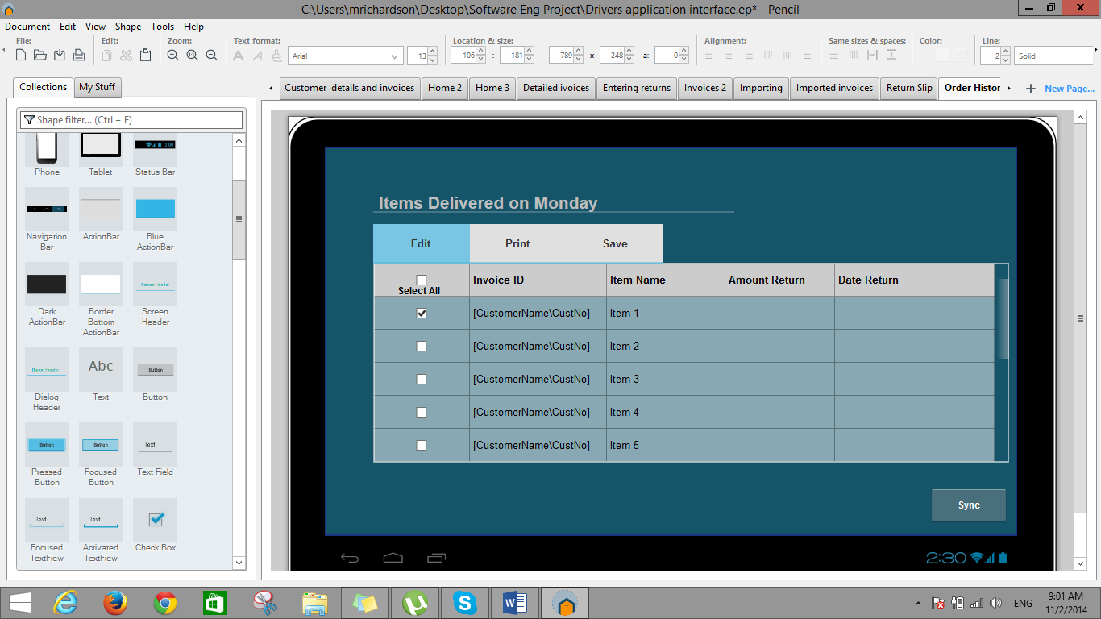

Figure5.3

Description:

Step 4

* Once the information was imported successfully the user should only see the interface displayed in Figure 5.3 when they click on the view history button. This is also due to the information already existing on the tablet for the specified day under the combo box for Delivery history.
* The user now have the options of editing, printing and saving this information once the information was imported.

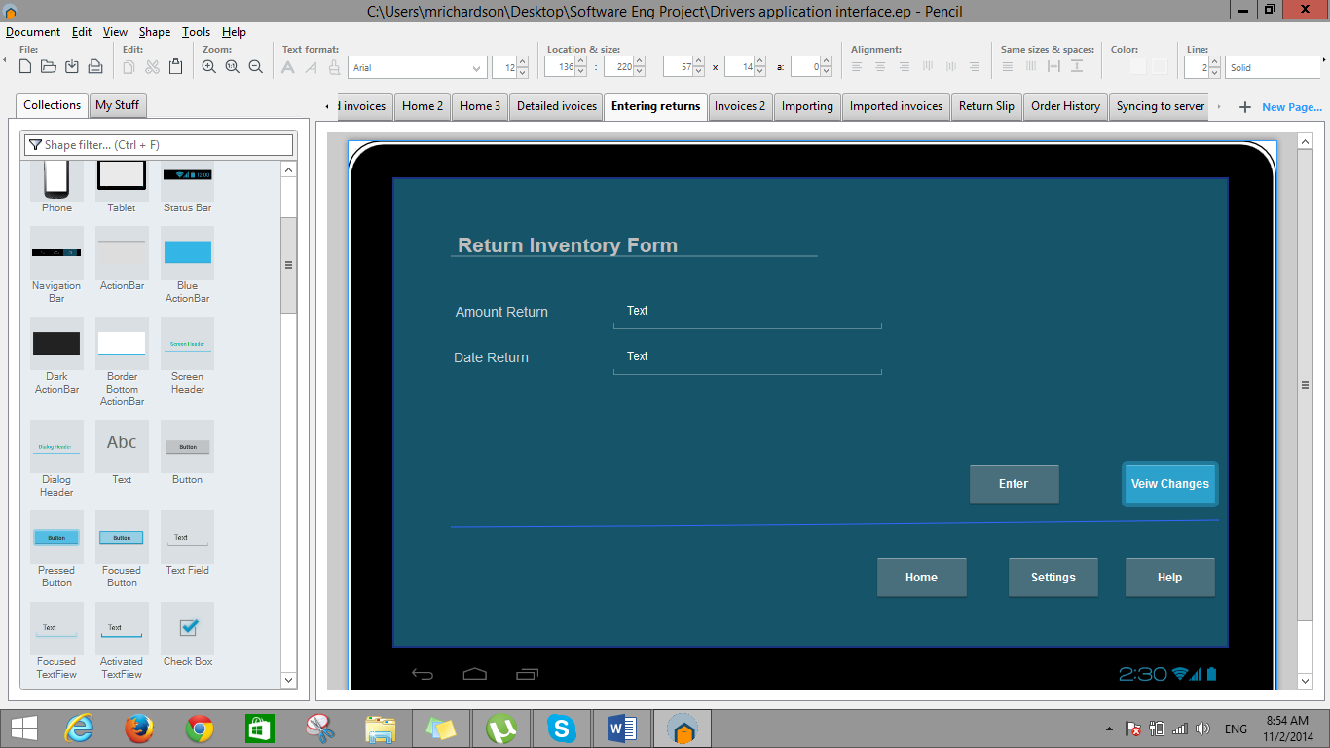

Figure 5.4

Description:

Step 5

* If the edit option was selected a form will appear for the user to enter the necessary information on a selected item and adjust accordingly. To view the changes made to the information, the user can then select the view changes button, where he can continue editing and saving the information.

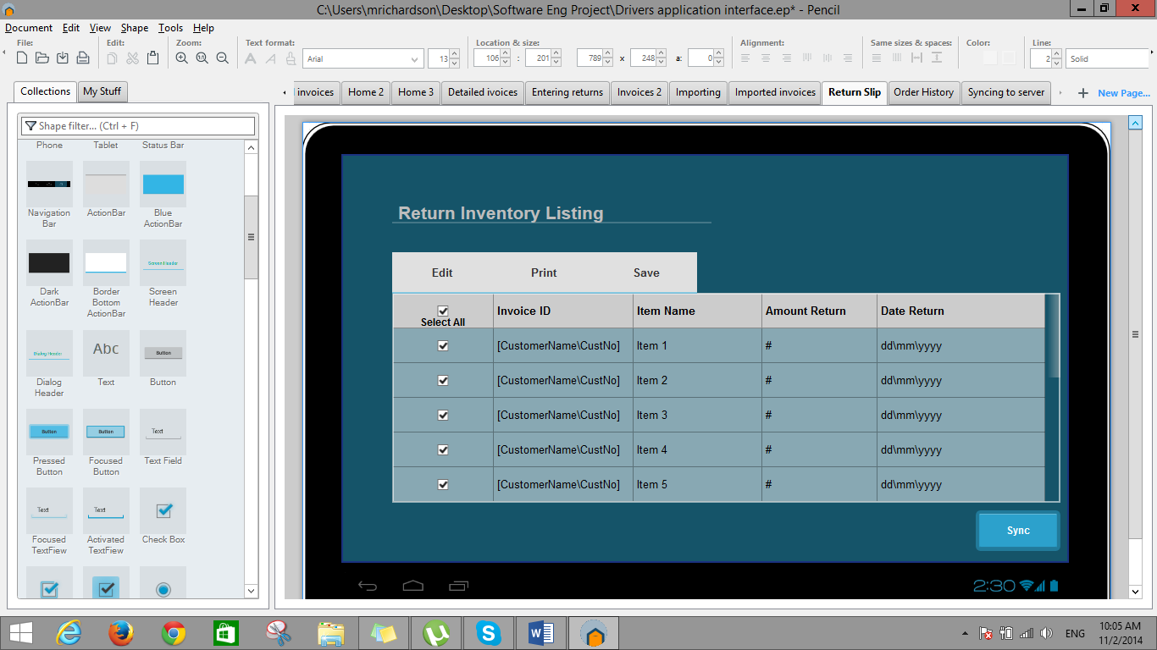

Figure 5.5

Description:

Step 6

* Once all changes have been entered, verified and saved the user can now proceed to synchronize the information to the main server. Synchronization will only be executable when the user have return to the bakery’s premesis.

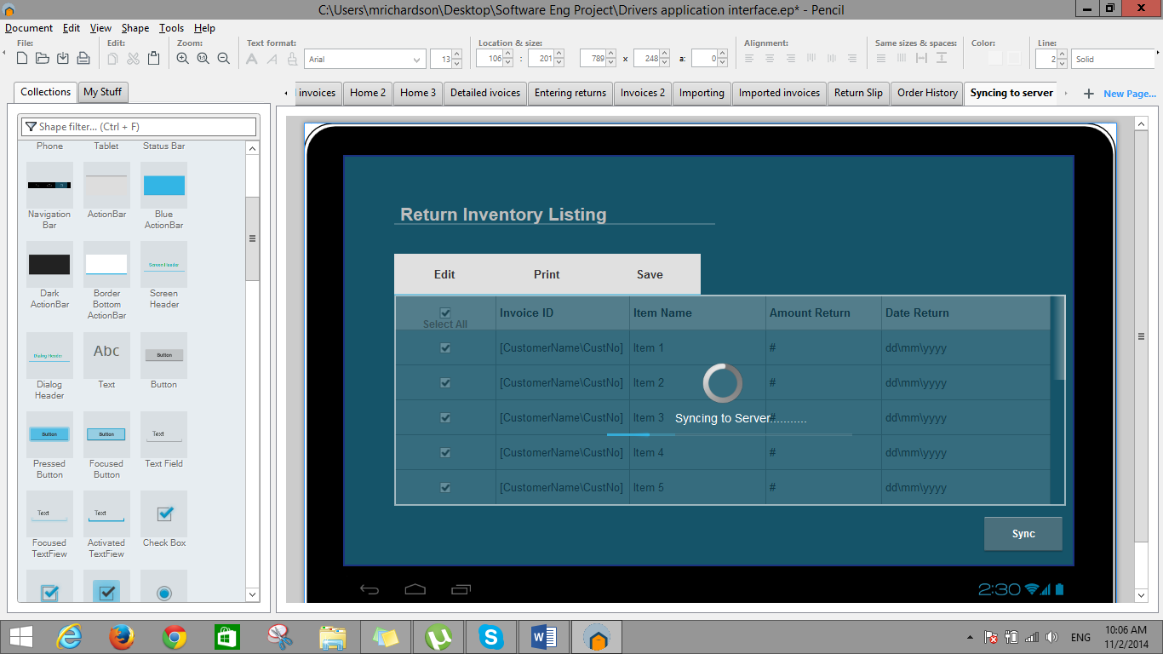

Figure 5.6

Description:

Step 7

* The interface in figure 5.6 shows the progress of the information being synchronized.

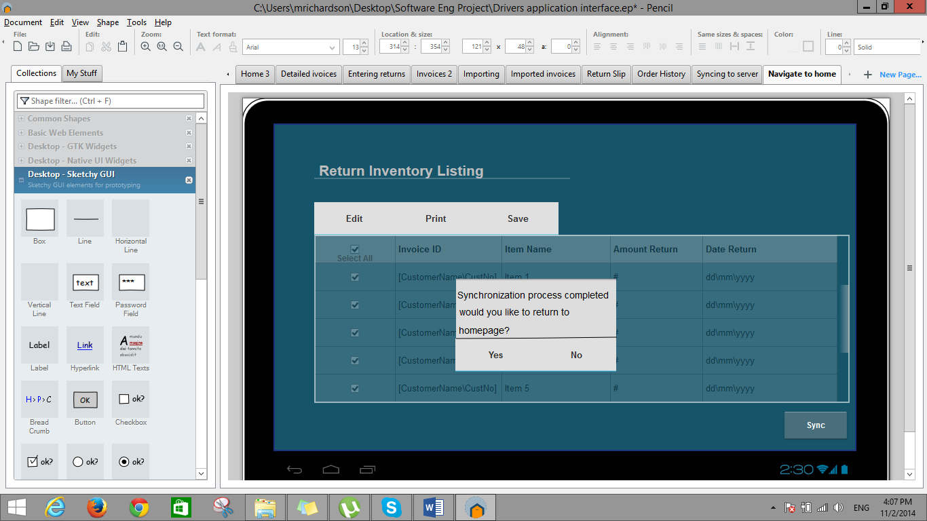

Figure 5.7

Description:

Step 8

* When the process is completed the application will now request if the user will like to navigate to the homepage. Mainly for them to logout of the application since the synchronization process is the final operation of their daily operations.